Action Number | CA20113
Action Name | PROTEOCURE
Action Title | A sound proteome for a sound body: targeting proteolysis for proteome remodeling
Action Dates | 01/11/2021 – 31/10/2025

Application for an ITC Conference Grant
The ITC Conference Grants support financially Young Researchers (<40 y.o.) and Innovators affiliated with an Inclusiveness Target Country (ITC) / Near Neighbour Country (NNC) (see Annex at the end of the document, for the list of ITC and NNC) for their participation in high-level conferences towards establishing a strong network and increase their visibility in the research community through sharing their work and acquiring new knowledge.
1. Applicant
Name
Laboratory (name of PI)
Position (PhD student, Post-doc, other)
e-mail
Phone
Name of the Institution
Institution Country

2. Conference details
Type of Conference (Face to Face or Virtual)
Conference title
Conference Web-page
Conference Venue
Conference Start and End dates

3. Accepted contribution details
Title of the presentation
Type of the presentation (oral/poster)
Co-authors
Other details of the presentation: (e.g. title of the session / track of the conference programme in which the contribution is accepted)

4. Relevance of the conference topic to the ProteoCure Action
Description of the relevance of the Conference to the Action (e.g., MoU objective, deliverable or WG task). (max.500 word)

Applicant enters max. 500-word summary here.

5. Motivation and expected impact
Description of the applicant’s motivation to participate in the conference and potential impact on the applicant’s career. (max.500 word)

Applicant enters max. 500-word summary here.

6. Justification of the Grant amount requested
Dates of travel
Transport type and cost
Accommodation cost
(specify the costs for accommodation and meals not included in the conference fee)
Conference fee
Other costs
(specify the type of cost and the amount)
Total Requested Budget

7. Additional Required Documents
Do not forget to send a copy of your abstract, a short CV and the acceptance letter from the conference organizer, together with this application form.

E-mail your ITC conference grant application package as a single pdf file entitled with your surname to the ProteoCure Meeting team (meetings@proteocure.eu). Please, write ITC Grant Application in the subject line of your e-mail.

ANNEX: List of the ITC and NNC (last update: July 2023)
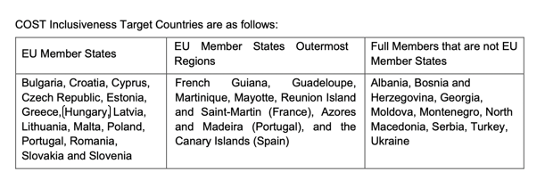
COST Near Neighbour Countries are:
Algeria, Azerbaijan, Egypt, the Faroe Islands, Jordan, Kosovo, Lebanon, Libya, Morocco, Palestine, Syria, and Tunisia.

